**Tiny-ML**

Requirements:

Ubuntu 18.04 (or higher)

R 3.6.3 (or higher)

R shiny package installed

Web browser Mozila Firefox or Chrome

After download and uncompress the Tiny_ML.zip:

1 - In a terminal, go to the folder Tiny_ML:

cd /home/**path_in_your_computer**/Tiny_ML

2 - Run the file **Install.sh** to install complementary libraries in the system:

sh Install.sh

3 - Run Tiny_ML:

sh Run.sh

If the web browser do not open automatically:

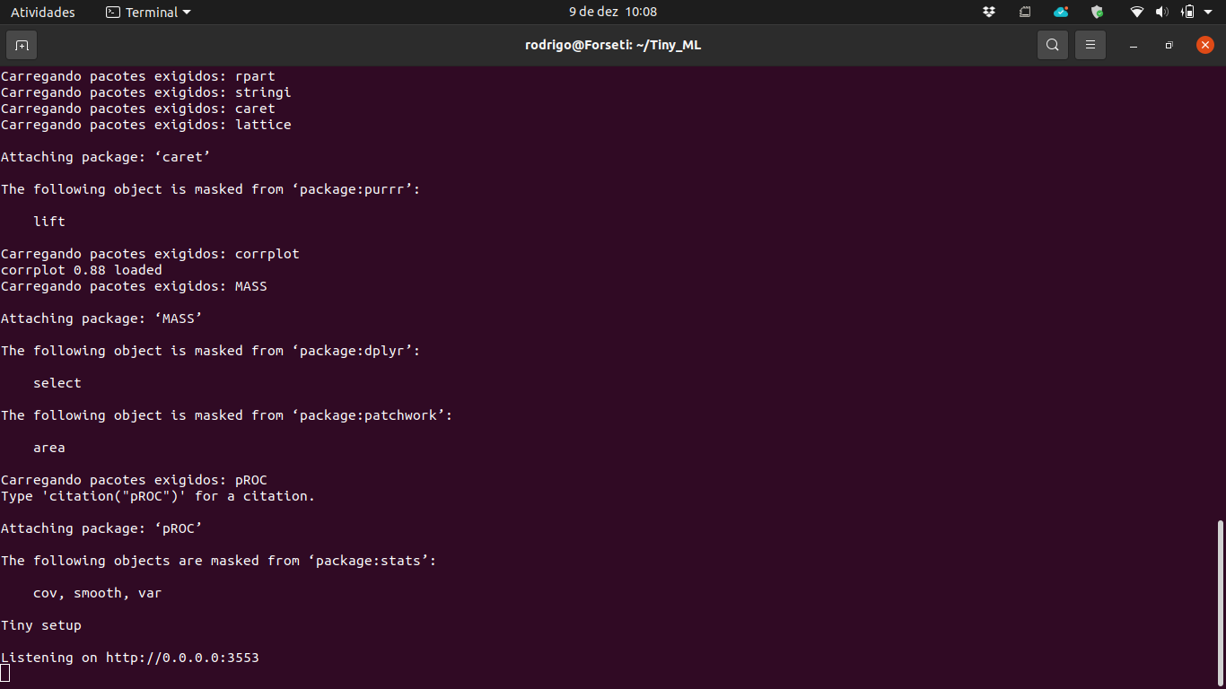

- Open your web browser;

- Type on the address bar: 0.0.0.0:3553

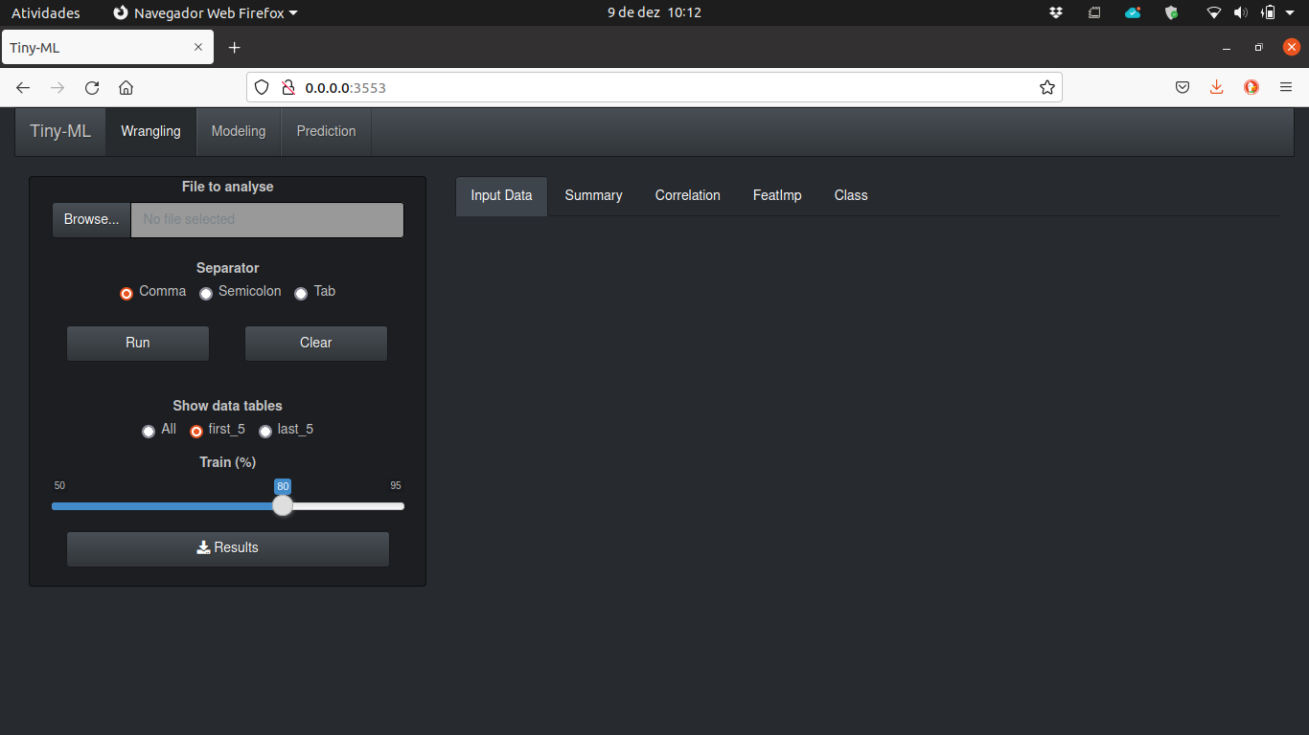

**Starting !**

**Wrangling**

The first step is to prepare your data. In the **Wrangling** tab, you will upload your file and select the rate of Train data set. After processing, you will see the follow screens:

1 - General data input visualization.

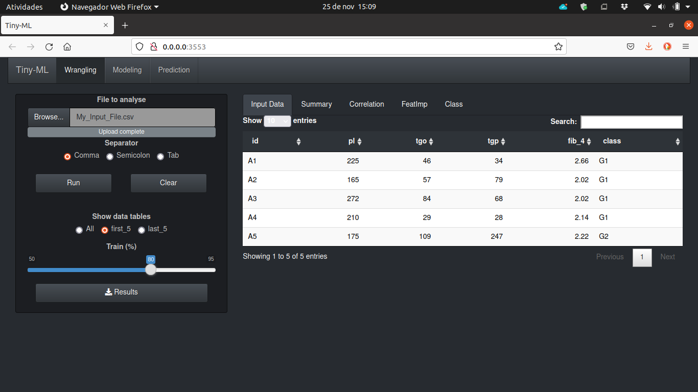

2 - Basic exploratory data analysis.

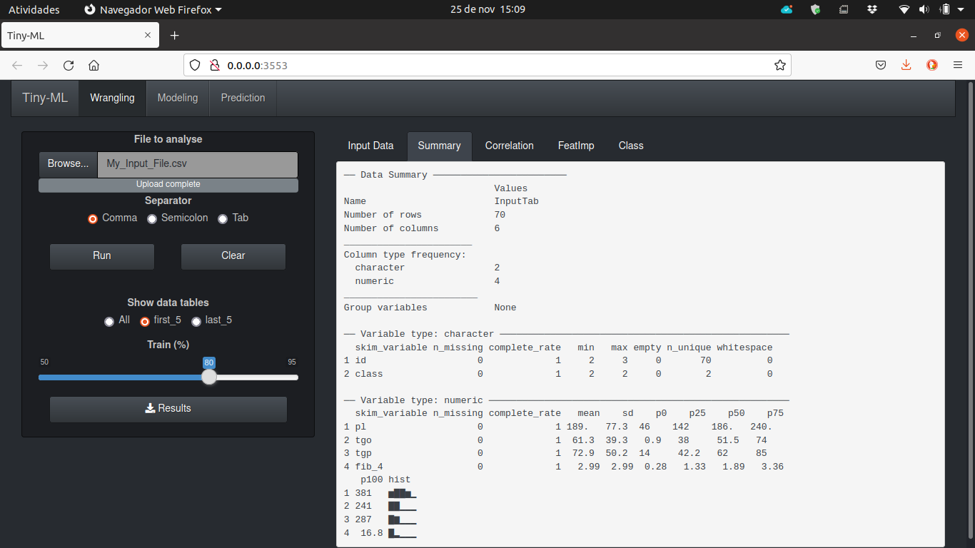

3 - Visualization of possible features correlation.

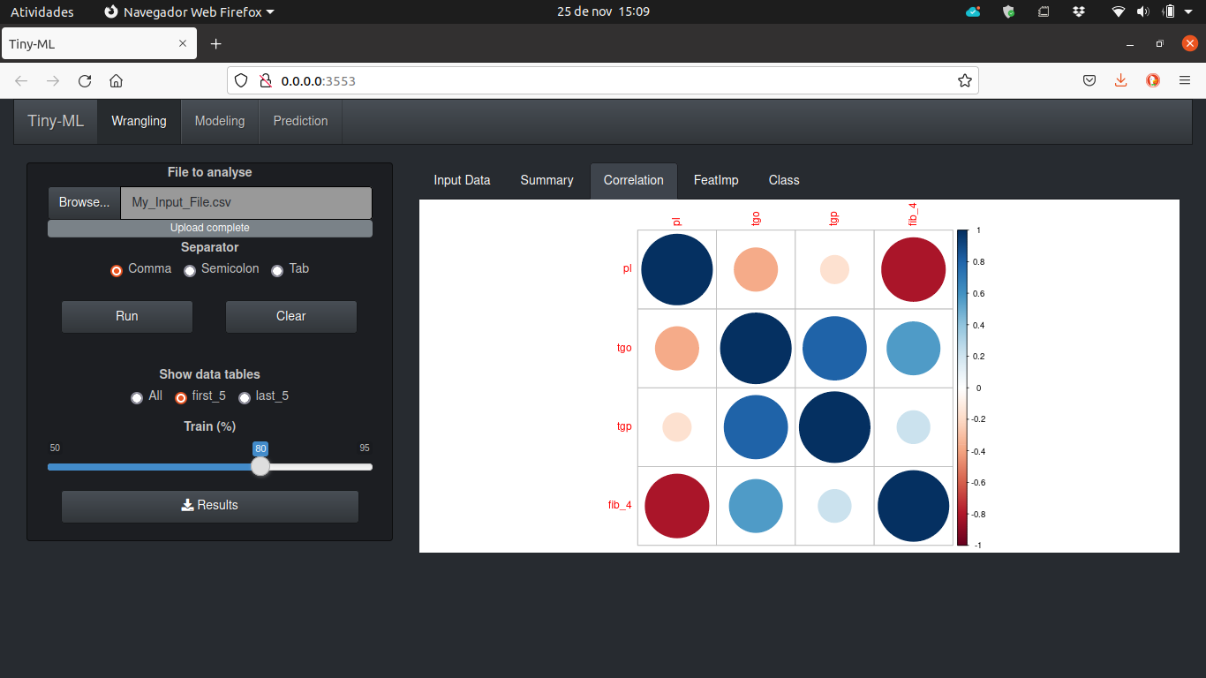

4 - Visualization of features importance.

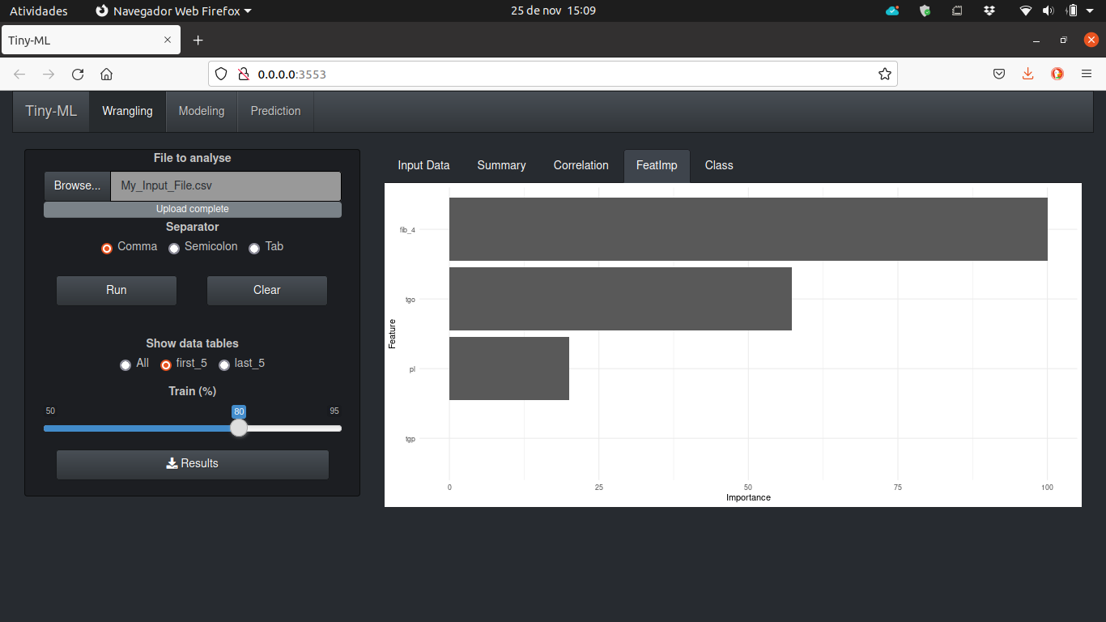

5 - Visualization of the class frequency.

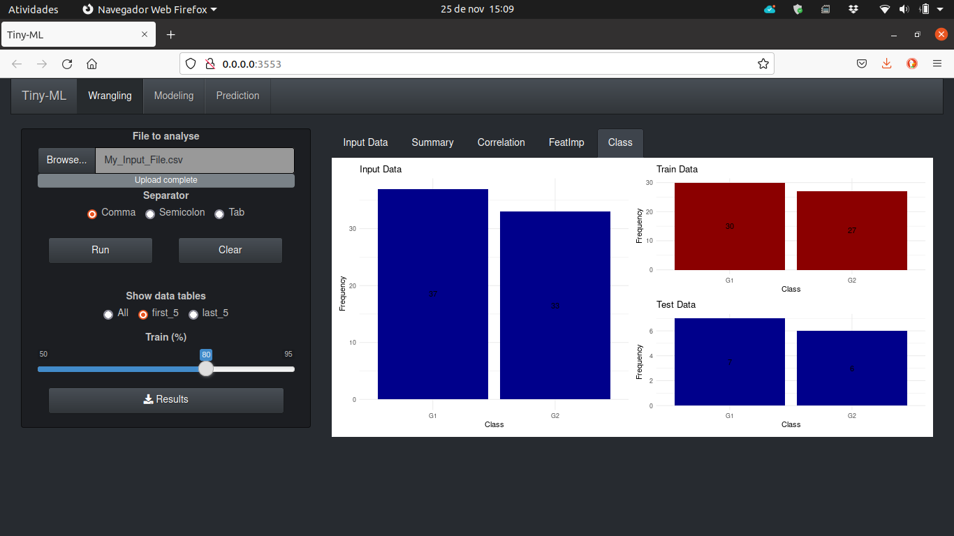

6 - After click download button.

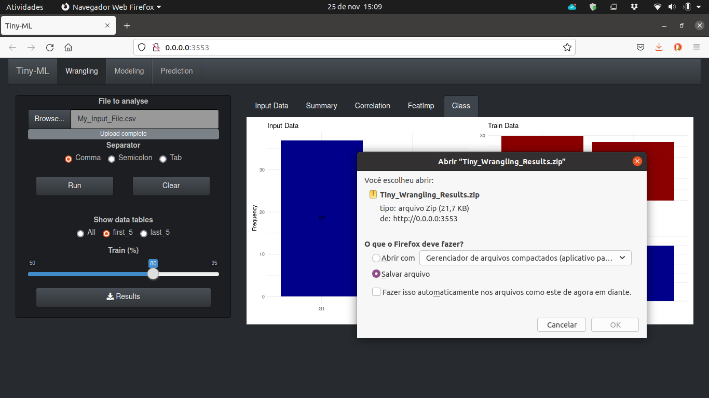

7 - Files present in the zip file.

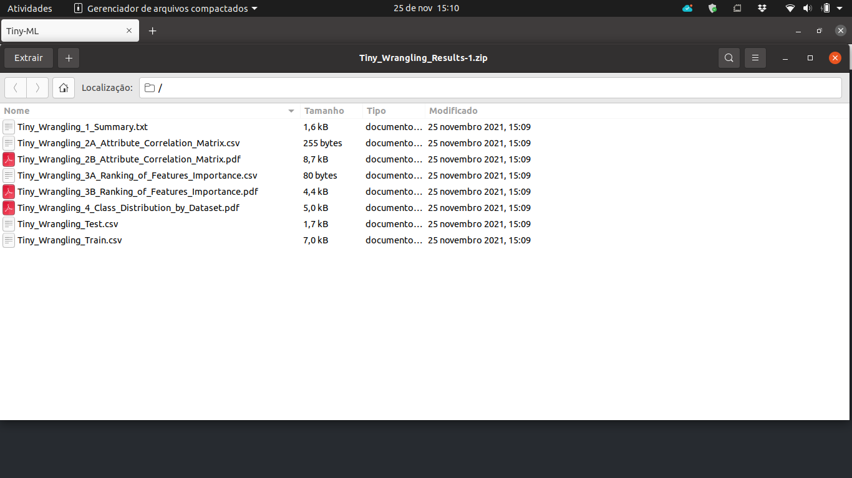

**Modeling**

After run Wrangling process, download and uncompress the zip file, you can start the modeling process. In the **Modeling** tab, you will upload the Train and Test files (simultaneously) and select the number of threads (or cores) to use.

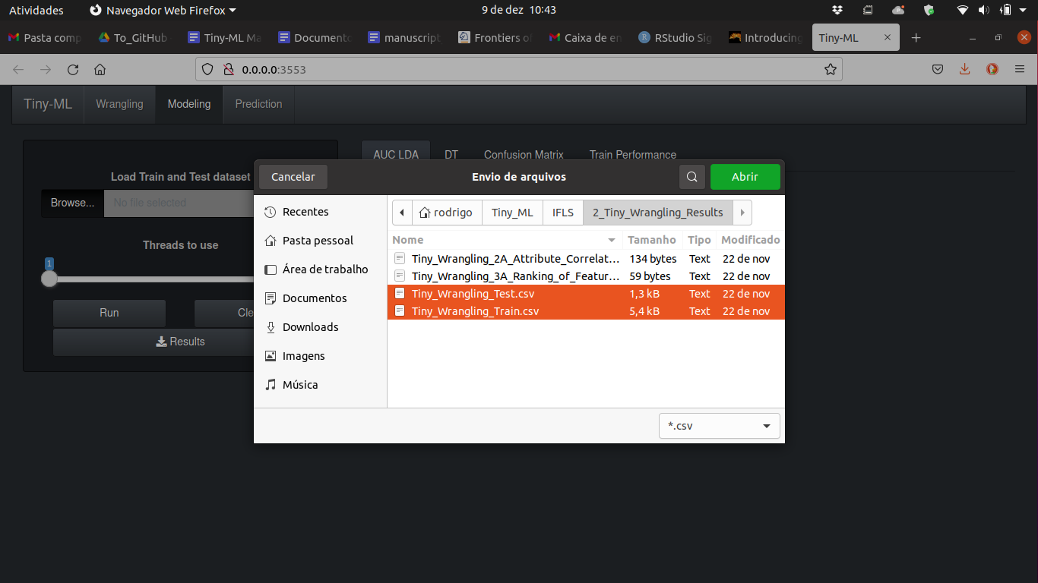

After processing, you will see the follow screens:

1 - Data distribution of AUC - LDA processing.

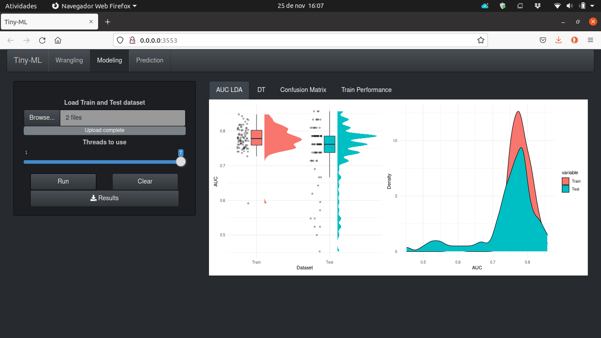

2 - Decision tree plot.

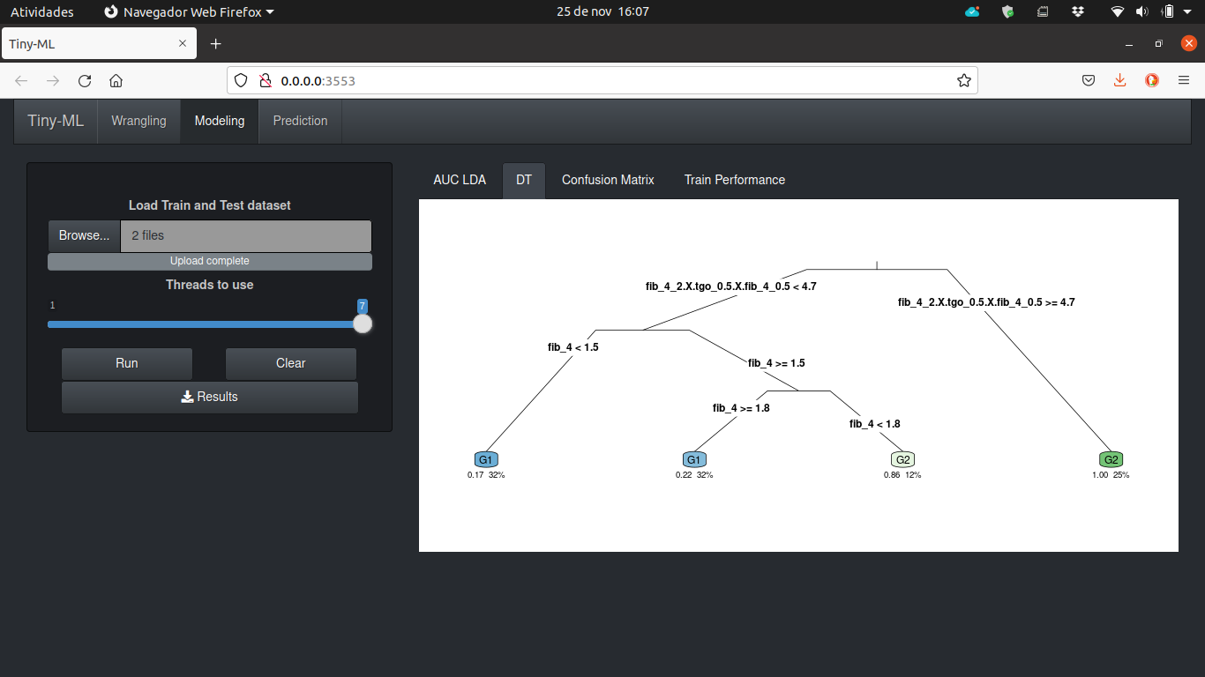

3 - Confusion matrix plot.

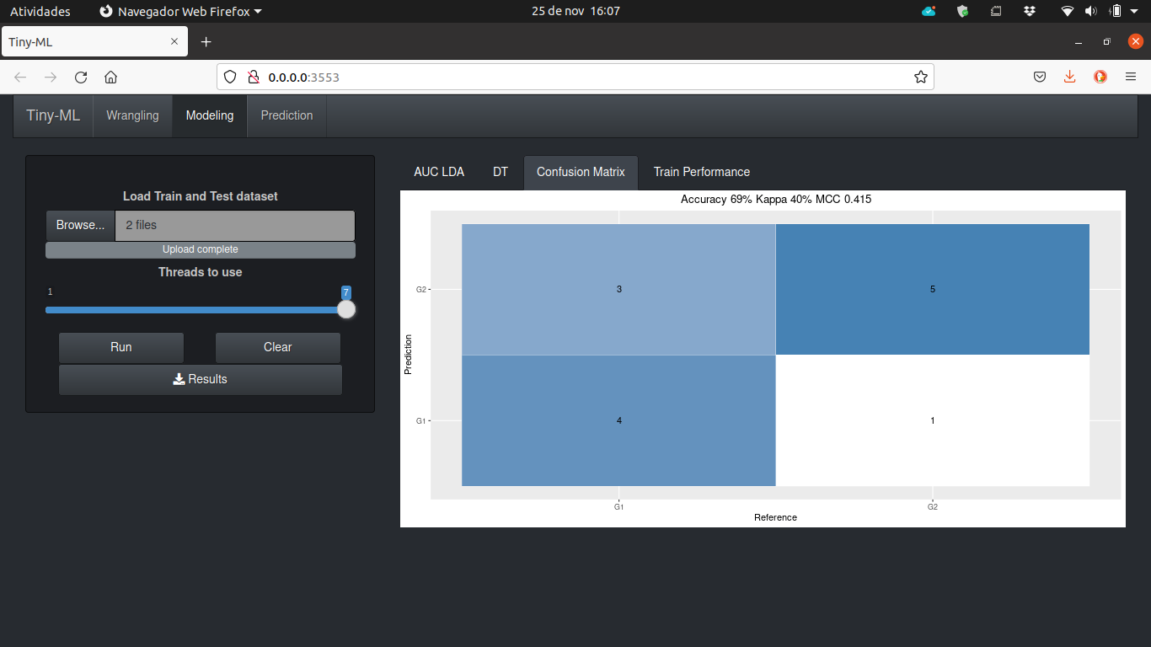

4 - Performance plot of the training classification.

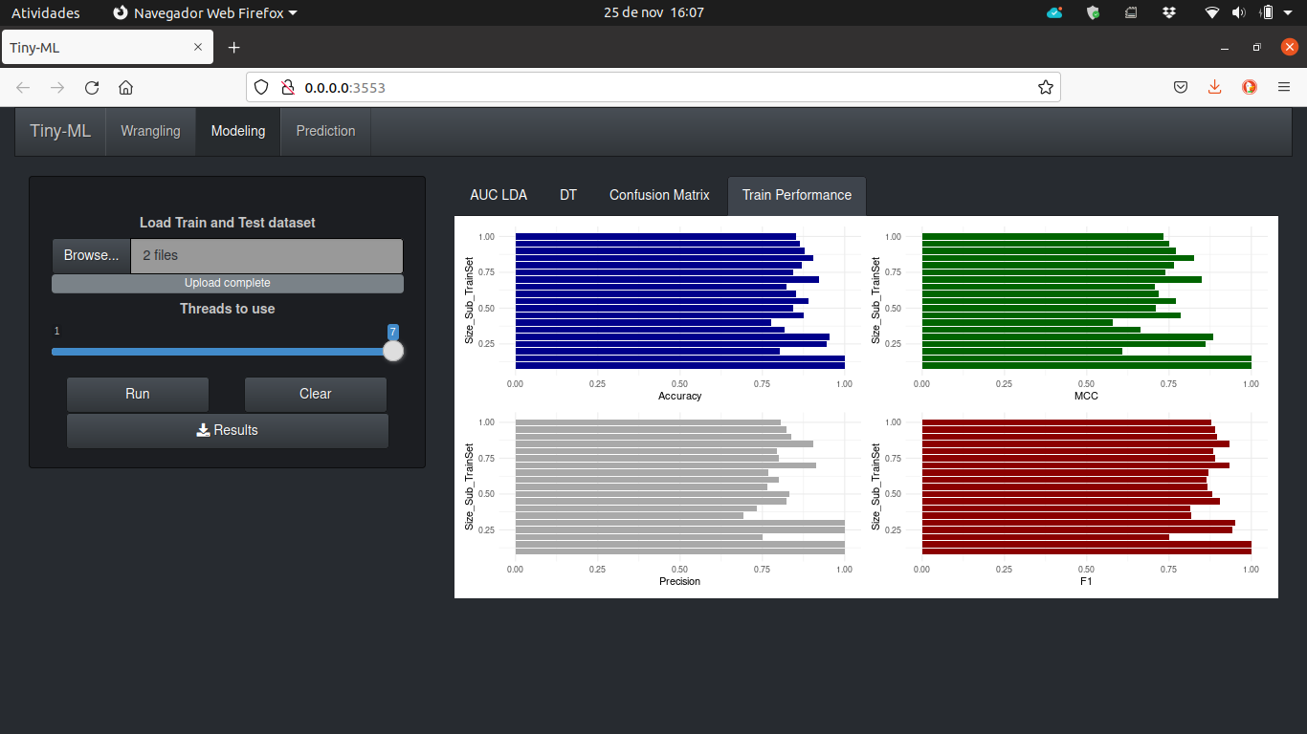

5 - After click download button.

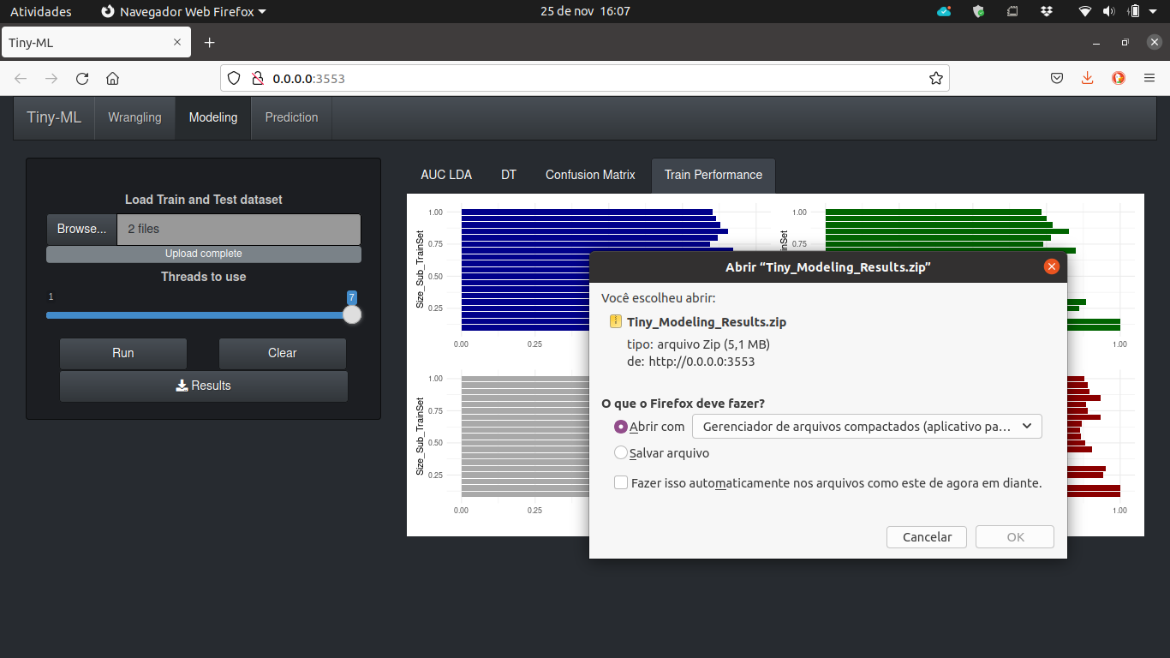

6 - Files present in the zip file.

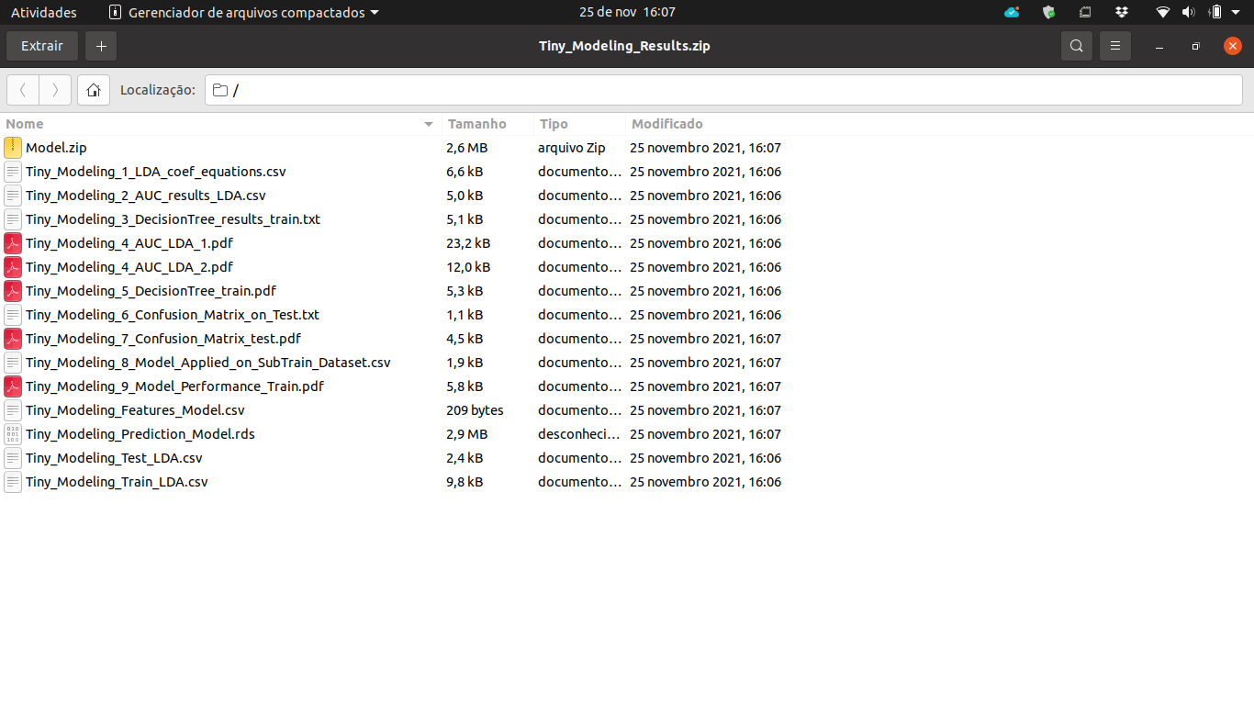

**Prediction**

After run Modeling process, download and uncompress the zip file, you can start the prediction process. In the **Prediction** tab, you will upload the files to predict and model.zip (from modeling process) and select the number of threads (or cores) to use. After processing, you will see the follow screens:

1 - Upload the files (dataset to predict and model.zip).

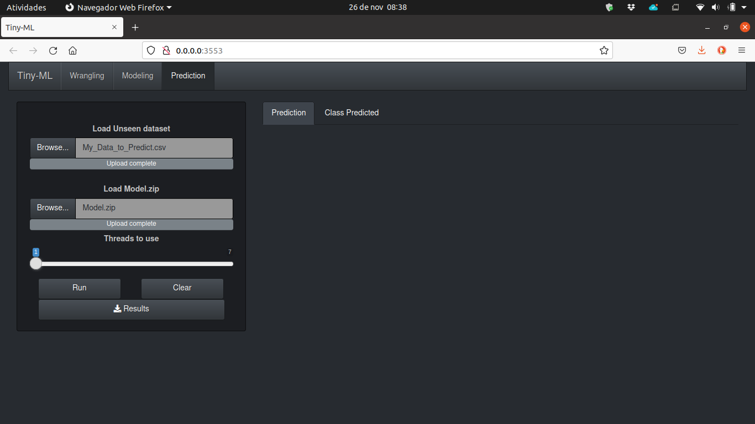

2 - Predictions in table format.

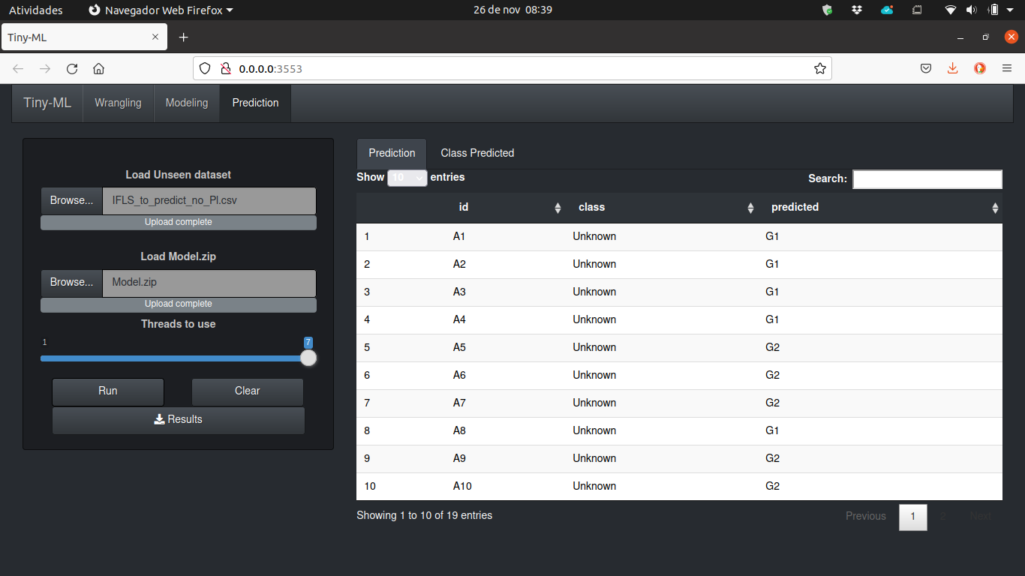

3 - Total of class prediction

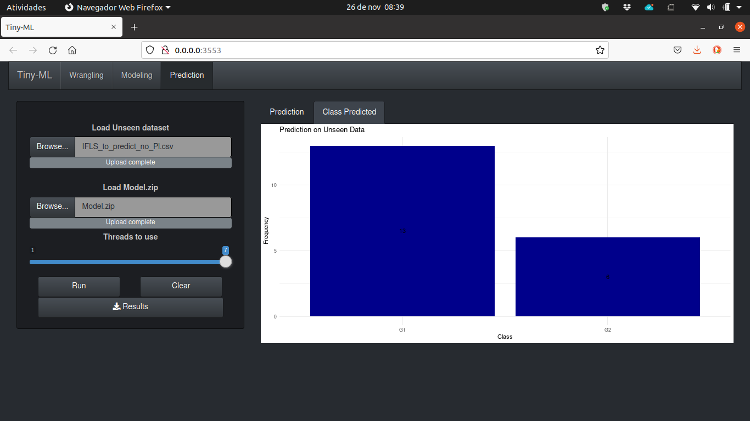

4 - After click download button.

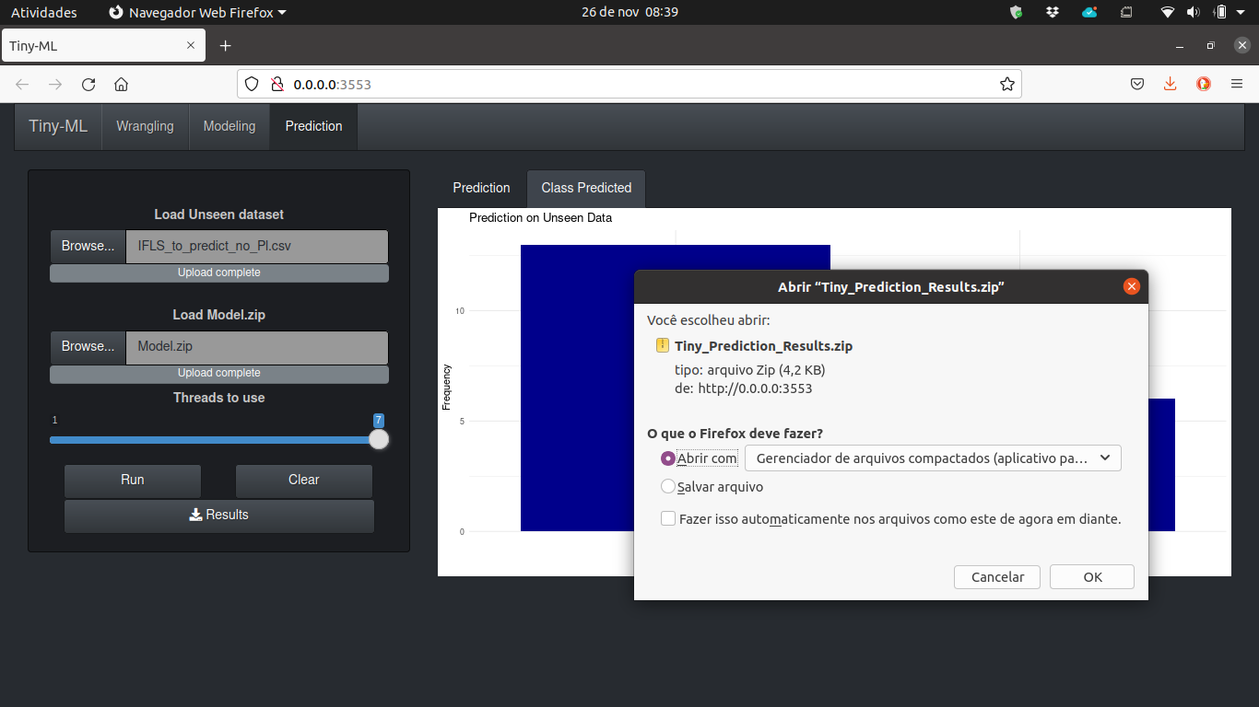

5 - Files present in the zip file.

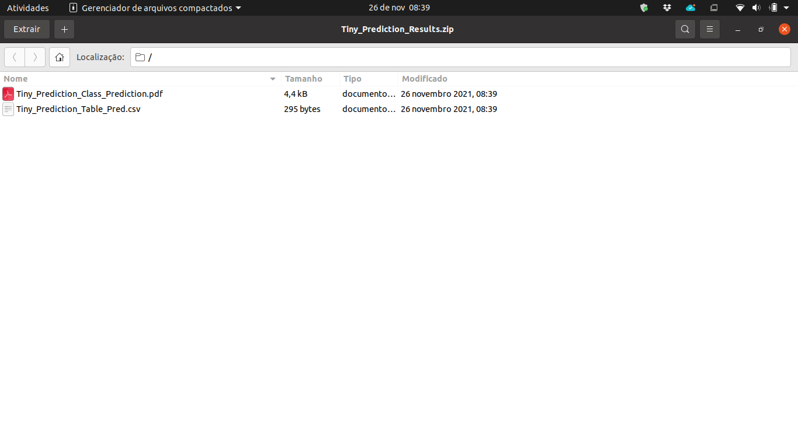

**Attention**

1 - Your **file to predict** needs to have identical headers of the **train/test file**. Thus, after you analyse the wrangling results and decide to remove some feature, you need to remove this same feature in the **file to predict**.

2 - Once you have generated the model, for future analysis (to the same context) you just need to use the tab **Prediction**.

3 - In the Examples folder, you will find files A_, B_ and Unknown. The file A_ is the original data, before the wrangling process. File B_ is a file created by removing some features, based on the wrangling results analysis. Thus, the Unknown file was projected to have a identical structure of B_ file (not the A_ file).